Title of the presentation

Author A.^{* 1}, a.author@univ-a.fr
Author B.², b.author@univ-b.edu
Author C.^{1,2}, c.author@univ-c.com

1: Université Grenoble Alpes – CNRS – Grenoble INP, 3SR, Grenoble, France
2: Université de Liège, Belgium

Abstract:

The abstract is limited to two pages, including figures and references. It must present the objective of the presentation, the framework of the study and show the originality of the work. One or two figures may be included. A short list of bibliographical references is requested.

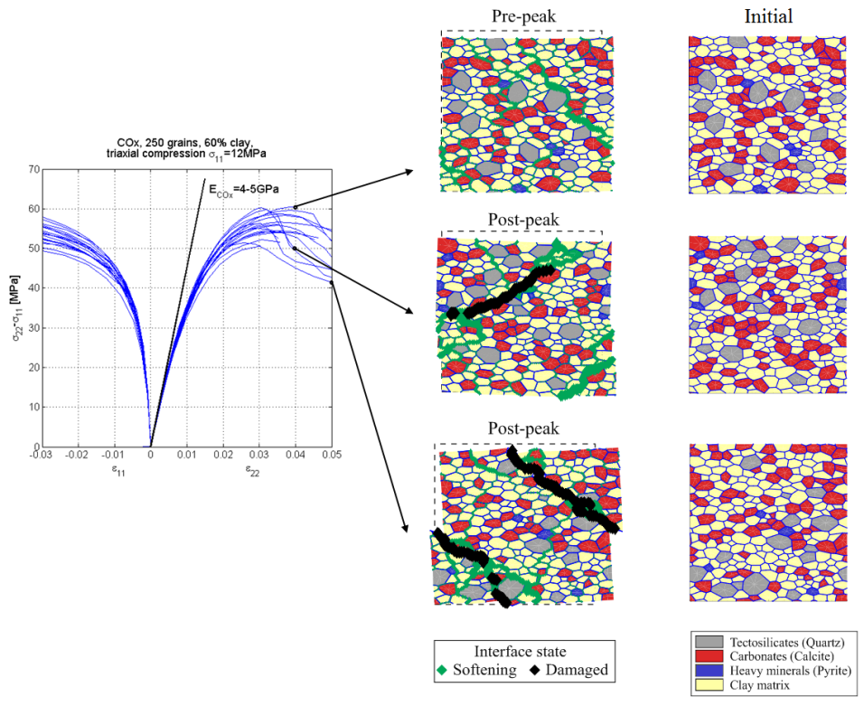
Figure 1: Material response at microscale under biaxial compression.

References:

[1] van den Eijnden, A.P., Bésuelle, P., Collin, F., Chambon, R., Desrues, J. (2017). Modeling the strain localization around an underground gallery with a hydro-mechanical double scale model; effect of anisotropy. Computers and Geotechnics. 85:384-400.

[2] Robinet, J.-C., Sardini, P., Coelho, D., Parneix, J.-C., Prêt, D., Sammartino, S., Boller, E., Altmann, S., (2012). Effects of mineral distribution at mesoscopic scale on solute diffusion in a clay-rich rock: Example of the Callovo-Oxfordian mudstone (Bure, France), Water Resources Research, 48, W05554.

